Create a new local user account in Windows Server 2016

When you install Windows Server 2016, the administrator account gets created by default, and it’s the account that is supposed to have the highest privilege on the server, you need to create a new local account in order to open all the applications. I think the reason behind this is that you shouldn’t use the administrator account to open non-administrative applications or download apps from the market, etc.

Anyway, creating a new user account in Windows Server 2016 is not much different than in previous windows serve and its very quick and simple, here is how, just **right-click** the **start**menu and then click on **Computer Management**

[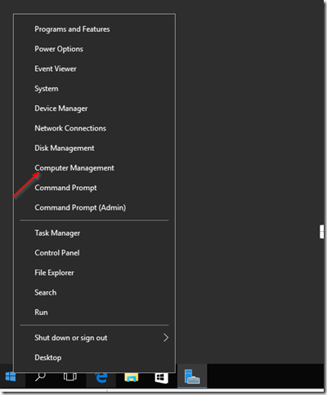](https://ittutorials.net/wp-content/uploads/image-111.png)

Then expand the **Local Users & Groups**tree and **right-click**on **Users** and choose **New User**:

[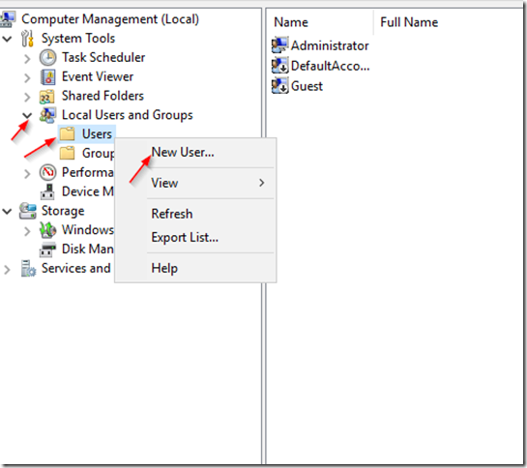](https://ittutorials.net/wp-content/uploads/image-112.png)

Fill out the New User form that comes up. remember to check **Password never expires**at the bottom:

[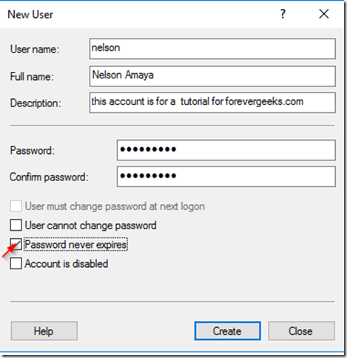](https://ittutorials.net/wp-content/uploads/image-113.png)

Then click on **Create.**

If you want to add this account to the **Administrators**group, then click on on the **Groups**folder under local Users and Groups and **double-click**on the **Administrators**group:

[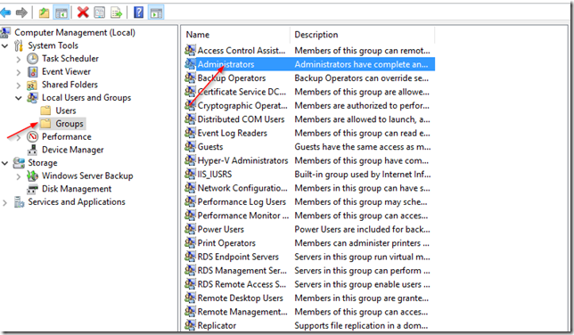](https://ittutorials.net/wp-content/uploads/image-114.png)

Then click on **Add**on the screen that popup,type the name of the account you just created,  then hit **Apply**then **OK**

[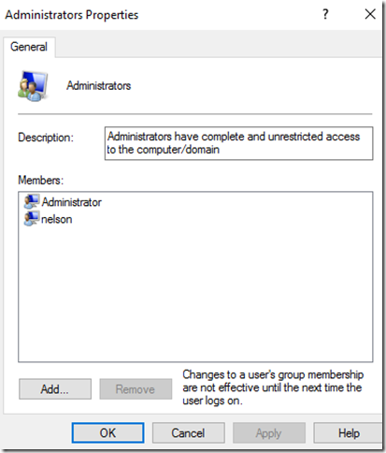](https://ittutorials.net/wp-content/uploads/image-115.png)

sign out from your administrator account:

[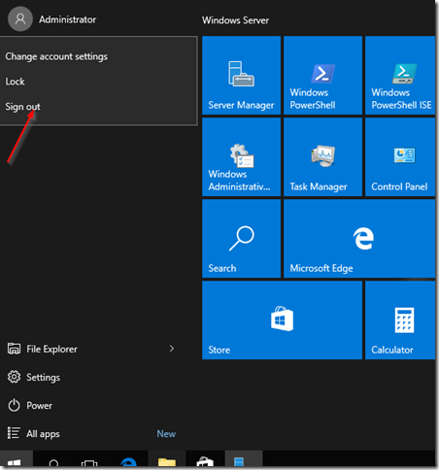](https://ittutorials.net/wp-content/uploads/image-116.png)